Level Editor Guidelines
All information is stored in the mesh and material (shader)
As a result it should be possible to easily export level segments - you can just export the mesh and material in a package and then import them into a different project and everything should work, even without the “Level” and “LevelEditor” classes (they’re only needed for editing)

Make the level in smallish segments
I don’t recommend making a whole level with one mesh just because currently have no “delete faces” tools or whatever. You can undo but if you make a full mesh and decide you want middle bit erased you’re gonna have to start from scratch (probably will add other tools to handle this later but not till after we’ve made demo and got the monies).
Note this won’t result in poorer performance because if anything off screen is culled anyway so if you make each level segment about a couple of screens wide then it won’t make a difference.

Materials
The tile selection grid can be fucked up, this is to do with Unity’s nasty copy pixels functions. Haven’t found a better way to do this yet. I usually have a reference image handy of the whole texture to help pick the right tile.
You can improve the appearance of textures by messing about with import setting (compression, mipmaps). However, this makes the tile selection even more weird (that damn copy pixels function!). So generally, edit first, change settings to make pretty later.
IMPORTANT!! - Use as few materials as possible. Ideally one with the whole tile map on.

Use split tool to create new tiles
I’ve found generally the best way of working is to build the basic geometry first then use the split tool to chop faces into the side you want to tile, then assign the tiles you want to those faces

UVs
If a tile looks upside down on distorted, select it and click the “Flip U/V” and “Flip U/V Origin” buttons till it looks right.

Flip U
Flips tile horizontally

Flip V
Flips tile vertically

Flip Origin
Determines which side the tile uses as it’s origin. For example, if the v coordinates use the top of the tile as an origin then the image will “follow” the direction of the top (e.g. If the top is sloped, the tile will distort to match that slope. If it’s straight, the tile will be straight). This may still be a bit buggy but when it works you can get some nice effects where the tiles follow the geometry of the mesh in a natural way. (See next page for visual example)

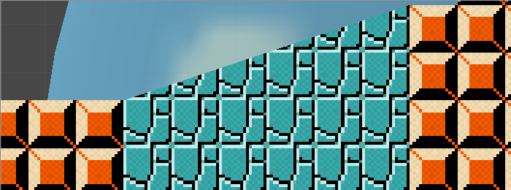
Origin is bottom so the tiles appear straight (because the bottom is straight)

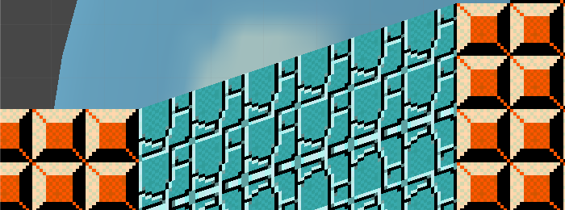
Origin is top so the tiles distort and follow the slope

